**Keep It Simple**

Common Components

* Header
* User Login
* Nav Bar
* Footer Area

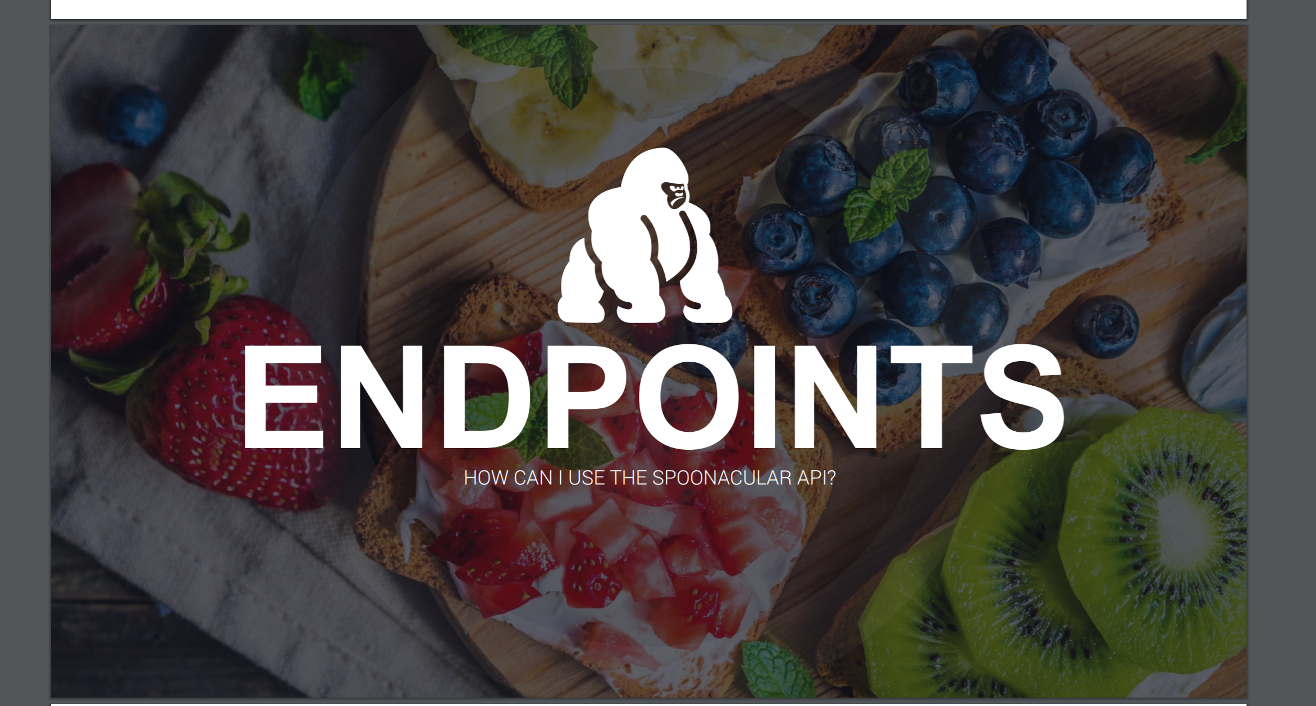

Landing Page

* Carousel
  + Some description on each slide

About Page

* Goals of the project
* Developer details

User Login Page (Modal)

* User name / email
* Password

Pantry Page

* Maintain available ingredients – (CRUD database)
* Select ingredients and go to Recipe page – 5
* Auto complete the ingredients - https://spoonacular-recipe-food-nutrition-v1.p.mashape.com/food/ingredients/autocomplete

Probably we can get ingredient pictures from <https://spoonacular.com/cdn/ingredients_100x100/apple.jpg>. We can make use of our cute fridge. https://spoonacular-recipe-food-nutrition-v1.p.mashape.com/recipes/visualizeIngredients

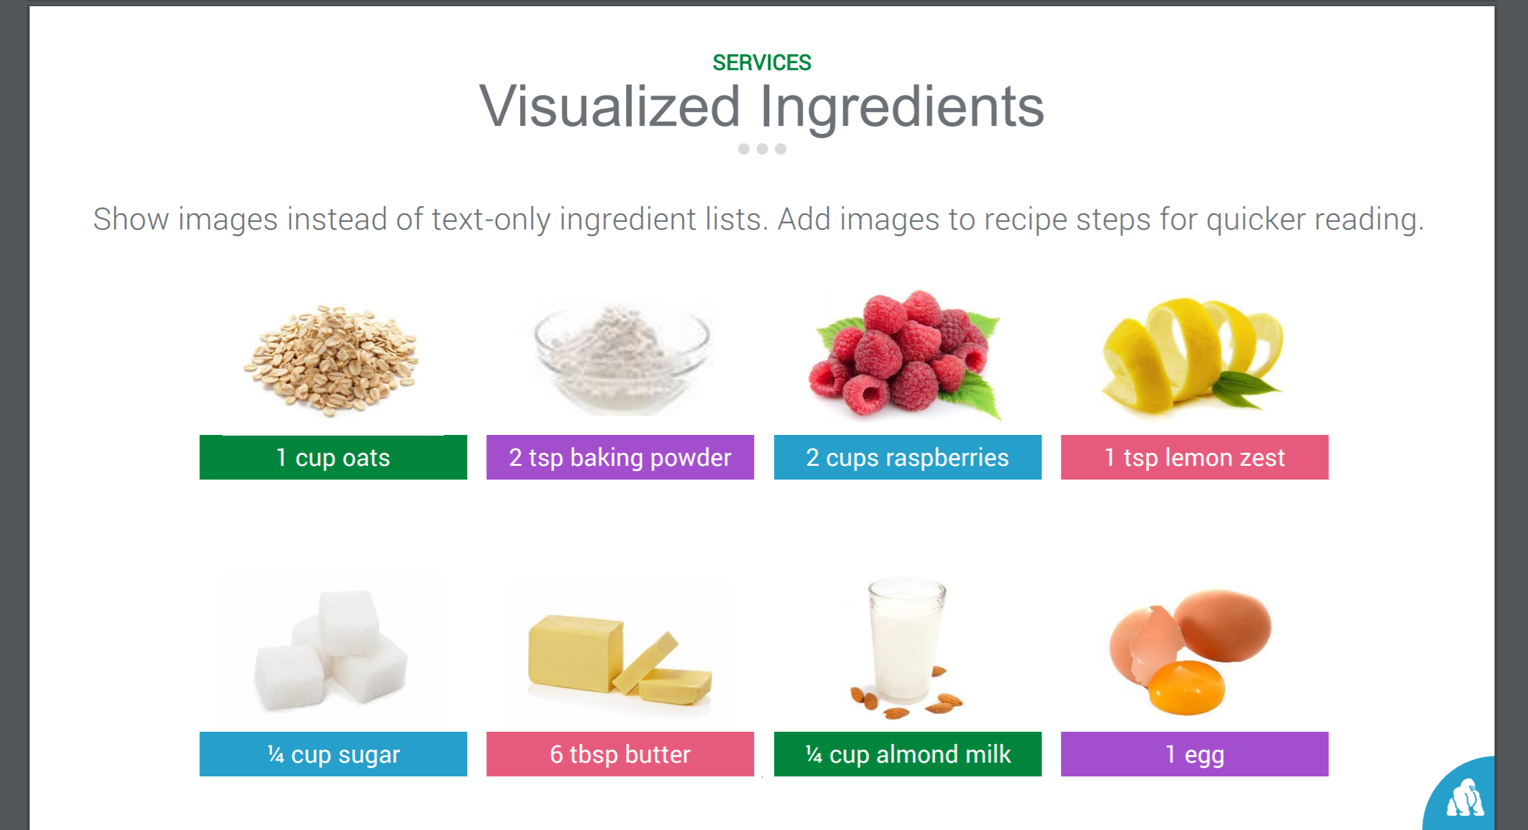

https://spoonacular-recipe-food-nutrition-v1.p.mashape.com/food/ingredients/autocomplete

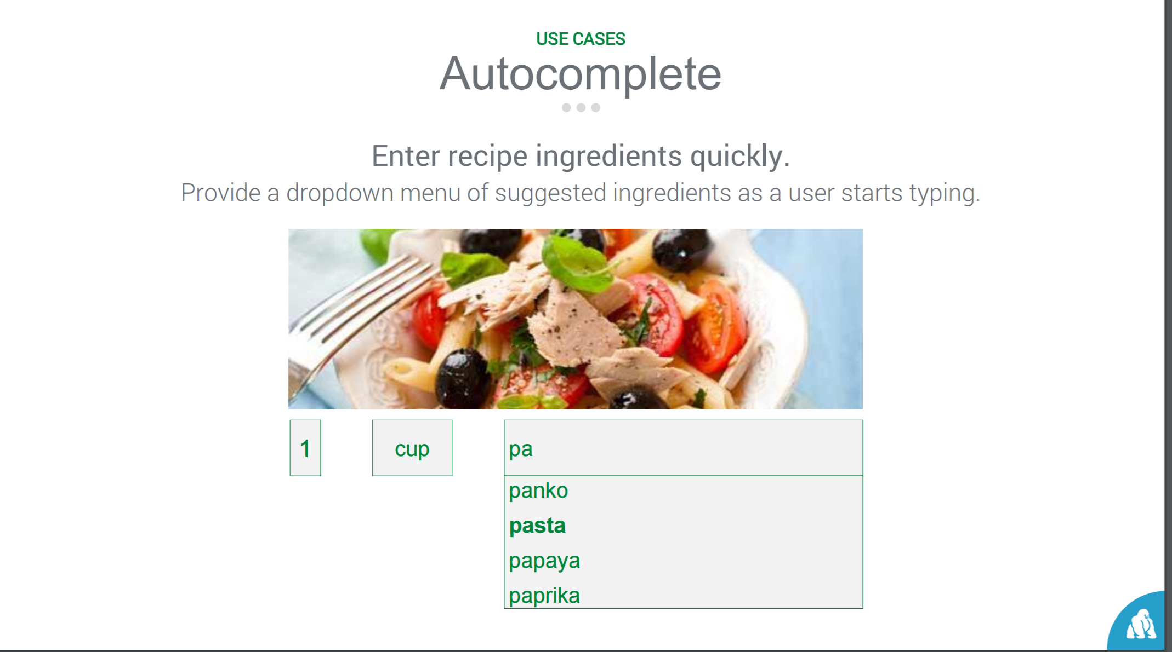

Recipe – Look UP

* Recipe by cuisine - <https://spoonacular-recipe-food-nutrition-v1.p.mashape.com/recipes/search>
* Popular Recipes - <https://spoonacular-recipe-food-nutrition-v1.p.mashape.com/recipes/random>
* By Ingredients - https://spoonacular-recipe-food-nutrition-v1.p.mashape.com/recipes/findByIngredients
* By Nutrition - <https://spoonacular-recipe-food-nutrition-v1.p.mashape.com/recipes/findByNutrients>
* By Daily Calories - https://spoonacular-recipe-food-nutrition-v1.p.mashape.com/recipes/mealplans/generate
* Recipe - Auto complete - <https://spoonacular-recipe-food-nutrition-v1.p.mashape.com/recipes/autocomplete>

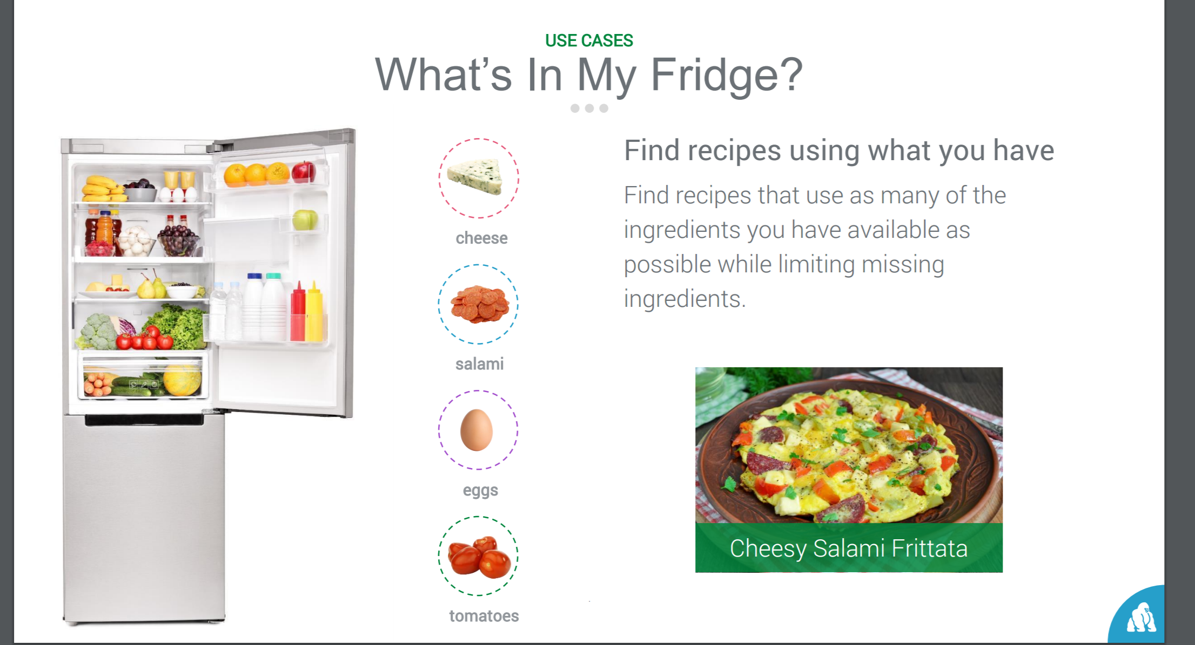 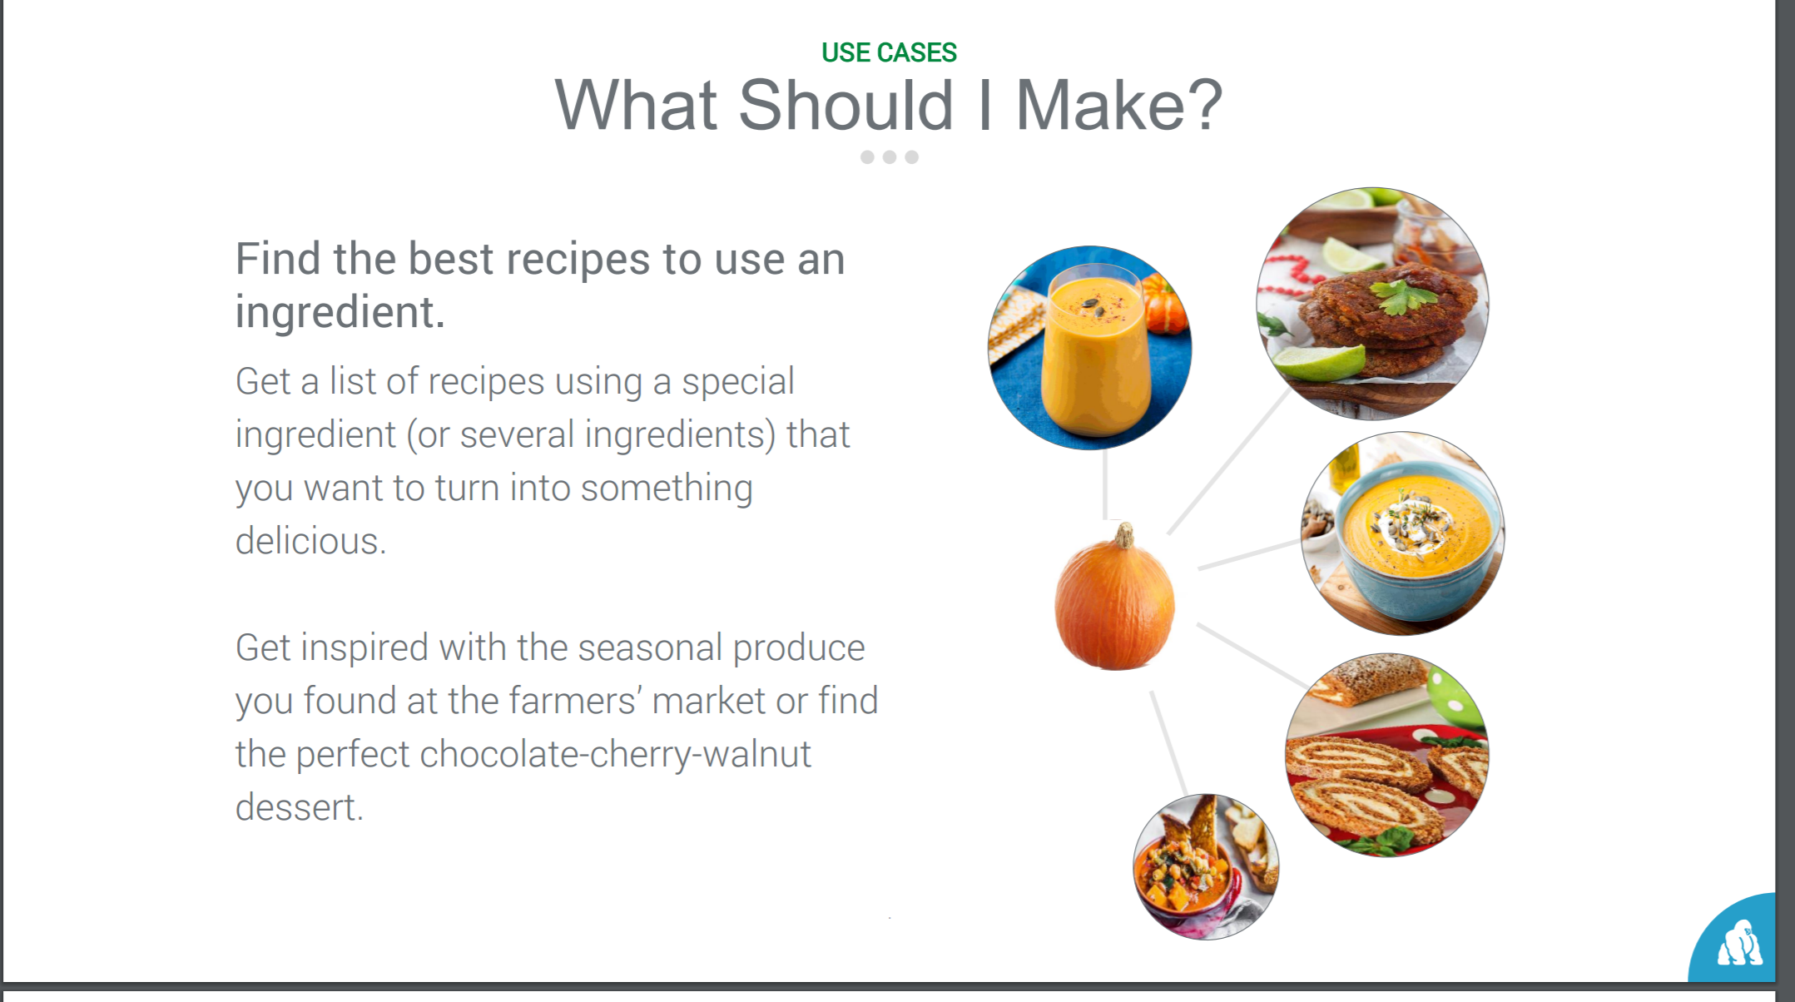

Recipe - Page

* Visualize ingredients of a recipe
* Visualize the equipment used to make a recipe. <https://spoonacular-recipe-food-nutrition-v1.p.mashape.com/recipes/visualizeEquipment>
* Get Analyzed Recipe Instructions - [https://spoonacular-recipe-food-nutrition-v1.p.mashape.com/recipes/{id}/analyzedInstructions](https://spoonacular-recipe-food-nutrition-v1.p.mashape.com/recipes/%7bid%7d/analyzedInstructions)

Get an analyzed breakdown of a recipe's instructions. Each step is enriched with the ingredients and the equipment that is used.

* + Step by step procedure (if possible)
    - Text
    - Picture
    - sound
  + Equipment & Ingredient picture
* Preparation time (if possible)
* Nutritional Information (thumb nail to modal) - https://spoonacular-recipe-food-nutrition-v1.p.mashape.com/recipes/visualizeNutrition
* Recipe Card (printable - optional) <https://spoonacular-recipe-food-nutrition-v1.p.mashape.com/recipes/visualizeRecipe>
* Similar recipes [https://spoonacular-recipe-food-nutrition-v1.p.mashape.com/recipes/{id}/similar](https://spoonacular-recipe-food-nutrition-v1.p.mashape.com/recipes/%7bid%7d/similar)
* Add / Delete the recipe - user database

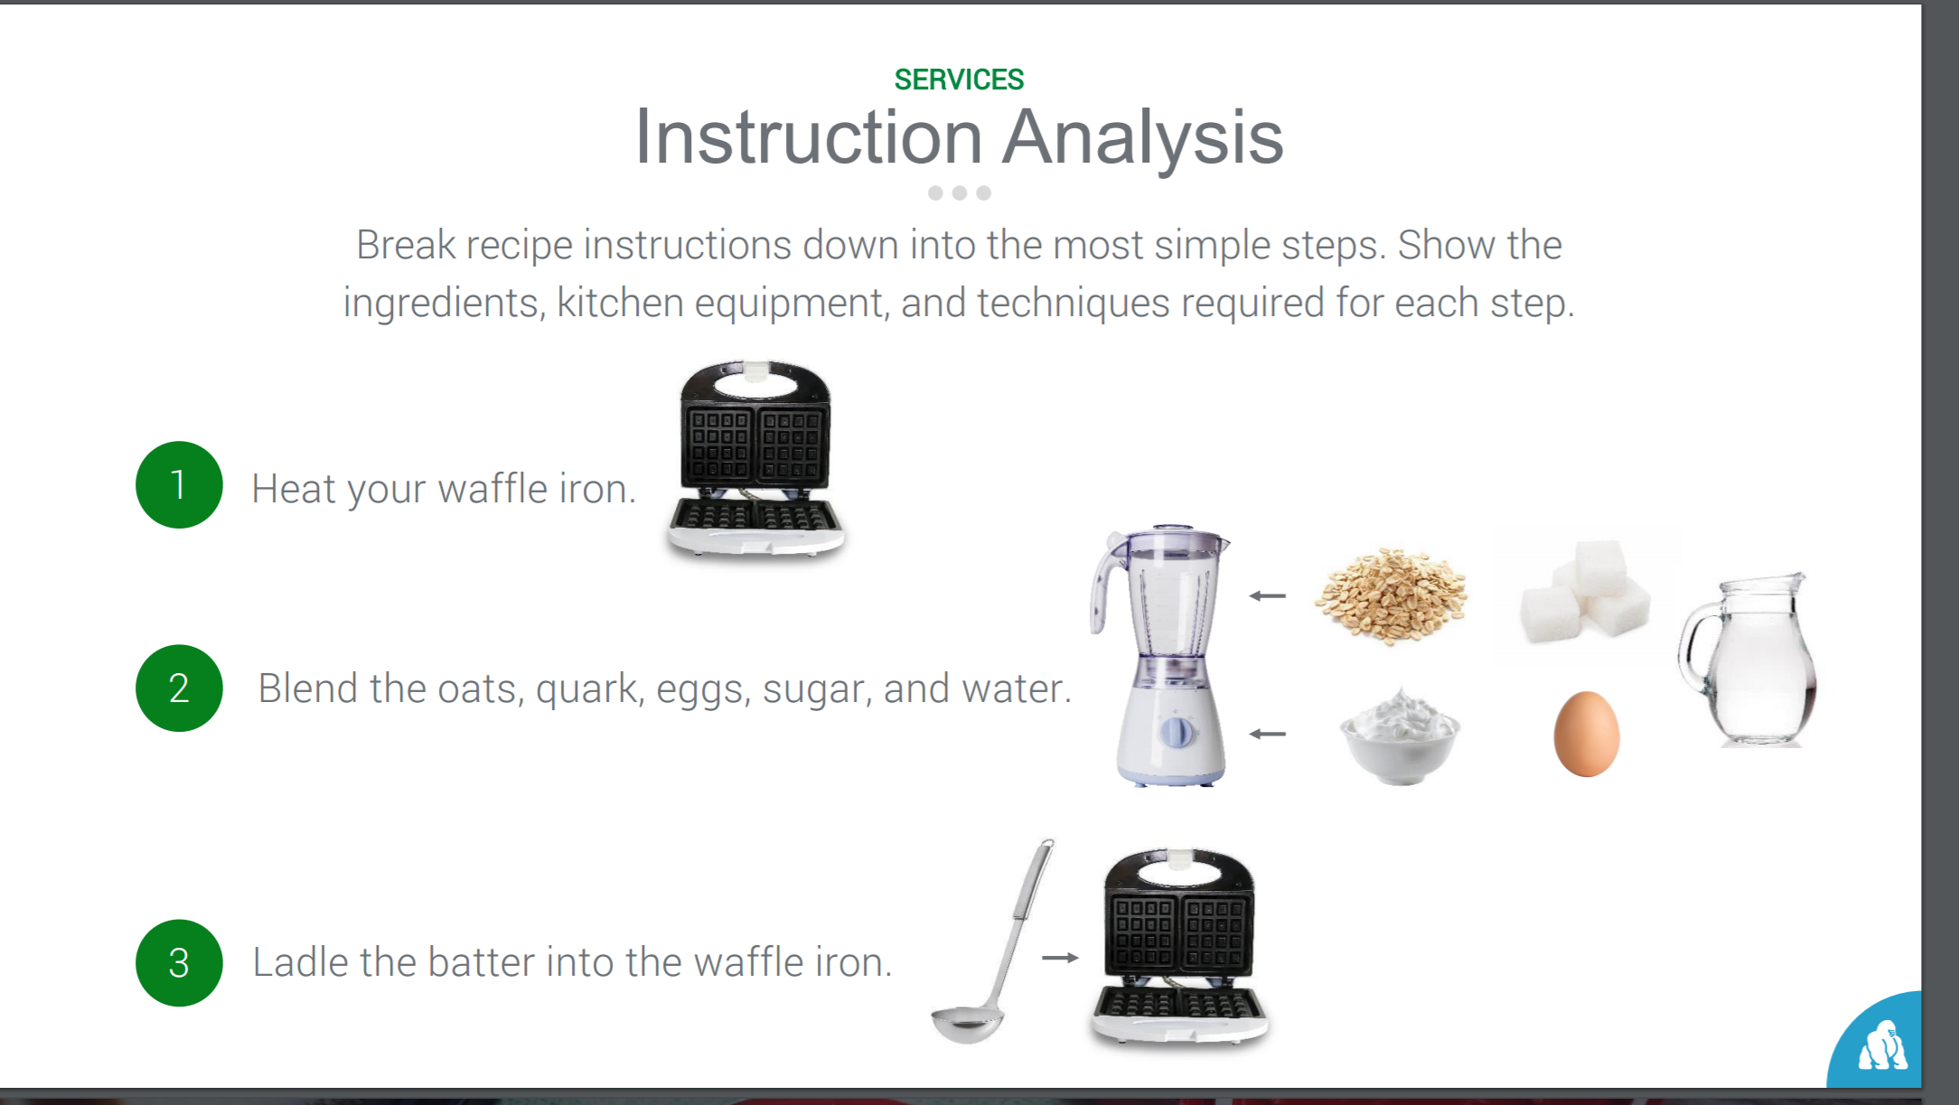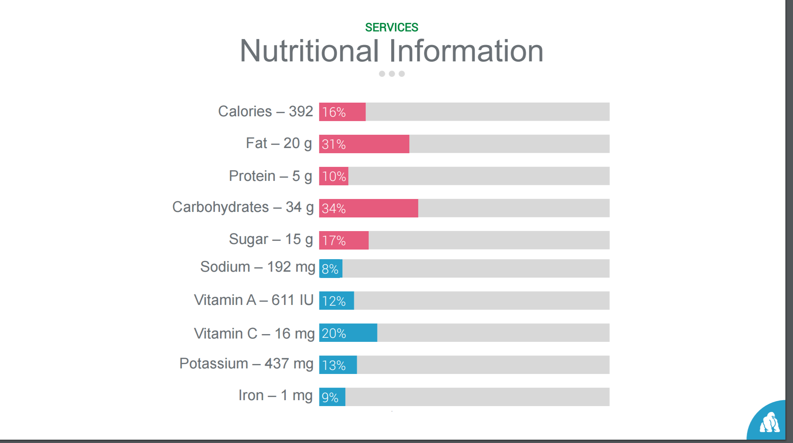

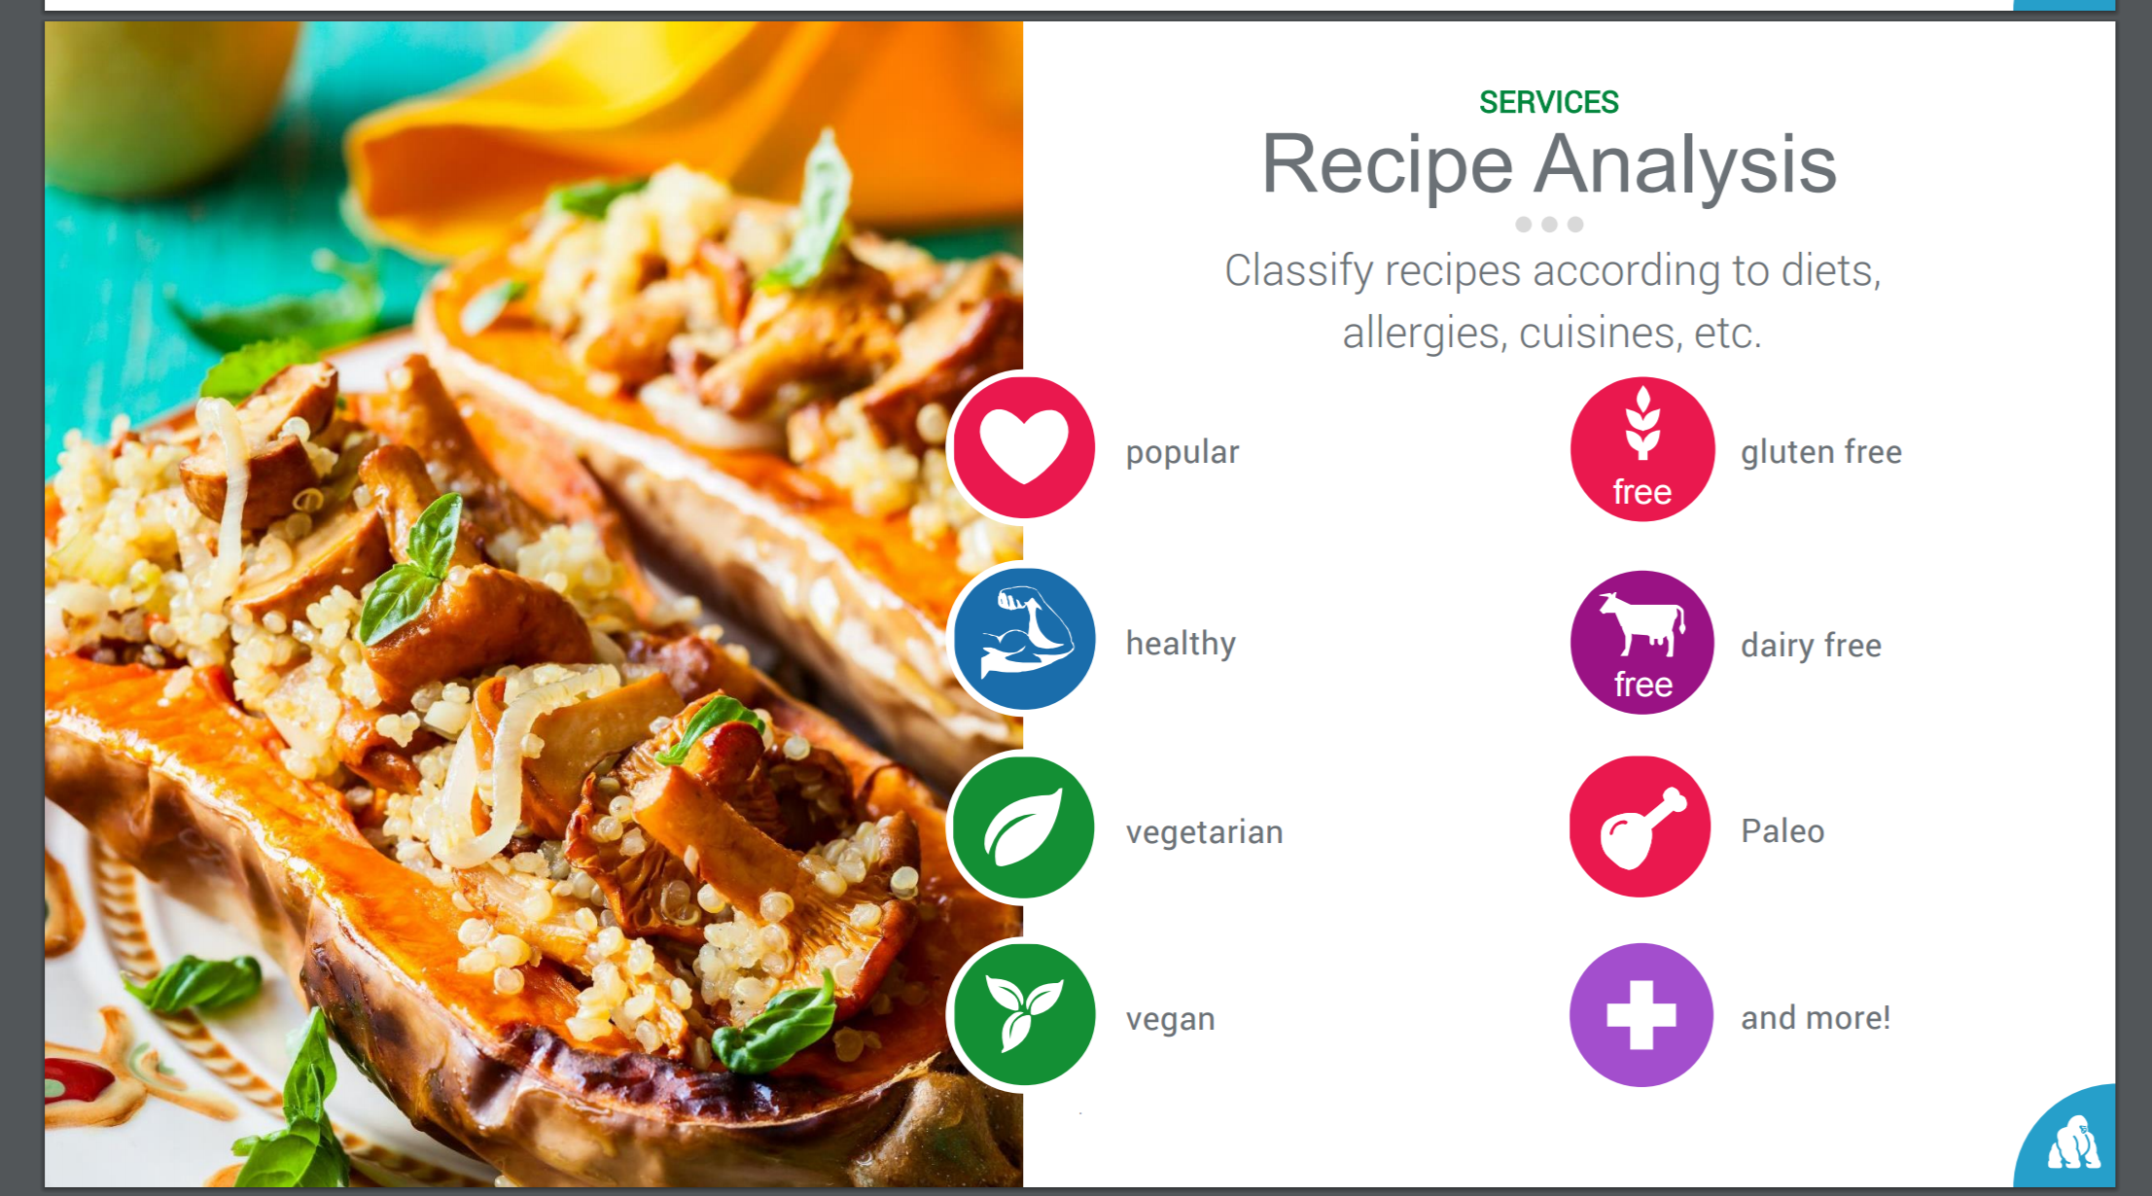 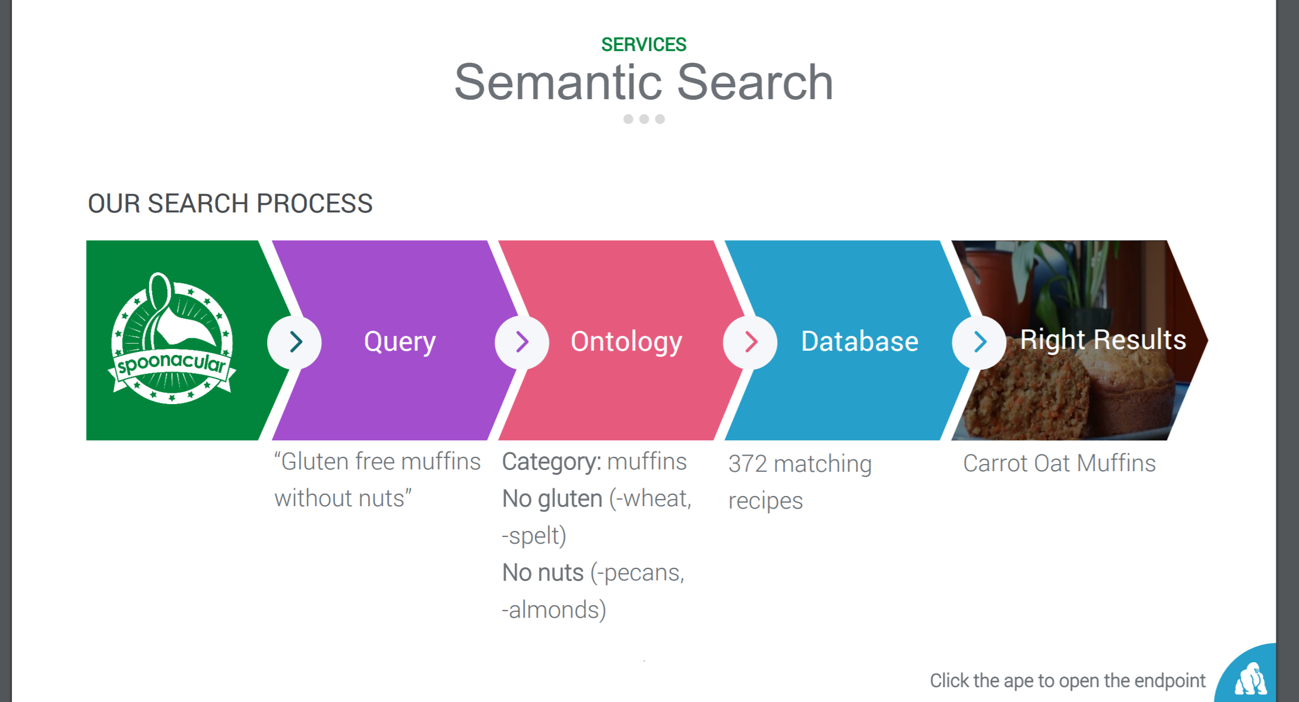

Grocery – Shop by Recipe

* Create grocery list. - https://spoonacular-recipe-food-nutrition-v1.p.mashape.com/food/ingredients/map
* Provide links for online order placement to local stores (Future )

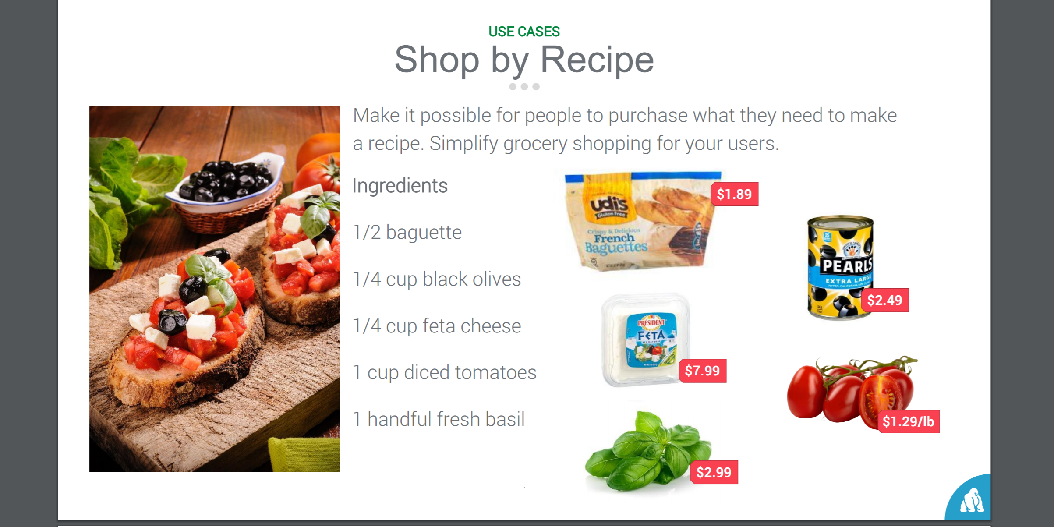

Meal Planning , Price Break Down & Smart Kitchen (Future)

